Semester One Examination, 2019

Question/Answer booklet

MATHEMATICS SPECIALIST
UNIT 3

Section One:

Calculator-free

Your Name

Your Teacher’s Name

Time allowed for this section
Reading time before commencing work: five minutes
Working time: fifty minutes

Materials required/recommended for this section
To be provided by the supervisor
This Question/Answer booklet
Formula sheet

To be provided by the candidate
Standard items: pens (blue/black preferred), pencils (including coloured), sharpener, correction fluid/tape, eraser, ruler, highlighters

Special items: nil

Important note to candidates
No other items may be taken into the examination room. It is your responsibility to ensure that you do not have any unauthorised material. If you have any unauthorised material with you, hand it to the supervisor before reading any further.

Question | Mark | Max | Question | Mark | Max
1 |  | 8 | 5 |  | 9
2 |  | 4 | 6 |  | 7
3 |  | 6 | 7 |  | 9
4 |  | 6

Structure of this paper

Section | Number of questions available | Number of questions to be answered | Working time (minutes) | Marks available | Percentage of examination
Section One:  Calculator-free | 7 | 7 | 50 | 49 | 34.5
Section Two:  Calculator-assumed | 13 | 13 | 100 | 95 | 65.5
 |  |  |  | Total | 100

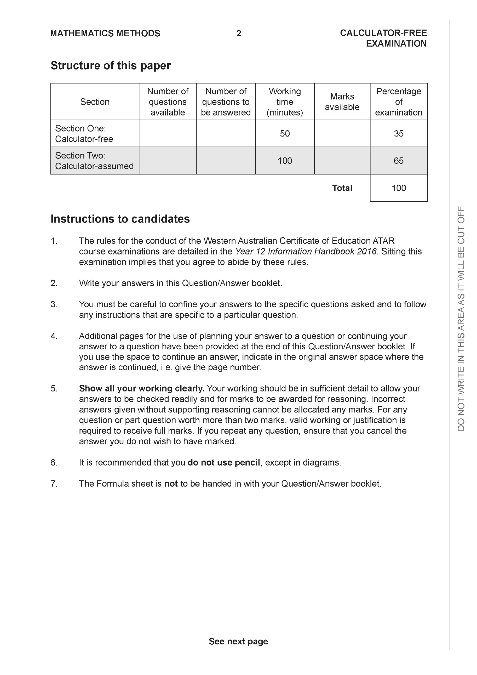

Section One: Calculator-free (49 Marks)

This section has seven (7) questions. Answer all questions. Write your answers in the spaces provided.

Spare pages are included at the end of this booklet. They can be used for planning your responses and/or as additional space if required to continue an answer.
● Planning: If you use the spare pages for planning, indicate this clearly at the top of the page.
● Continuing an answer: If you need to use the space to continue an answer, indicate in the original answer space where the answer is continued, i.e. give the page number. Fill in the number of the question that you are continuing to answer at the top of the page.

Working time: 50 minutes.

Question 1 (8 marks)

Let and .
- Determine (Simplify) (2 marks)

- Does exist over the natural domain of ? Explain. (2 marks)

- Determine and its natural domain. (4 marks)

Question 2 (4 marks)

Let where are real constants. Determine all possible value(s) of .

Question 3 (6 marks)

Solve for in the following system of linear equations.
Question 4 (6 marks)
Sketch the following function on the axes below showing all major features.

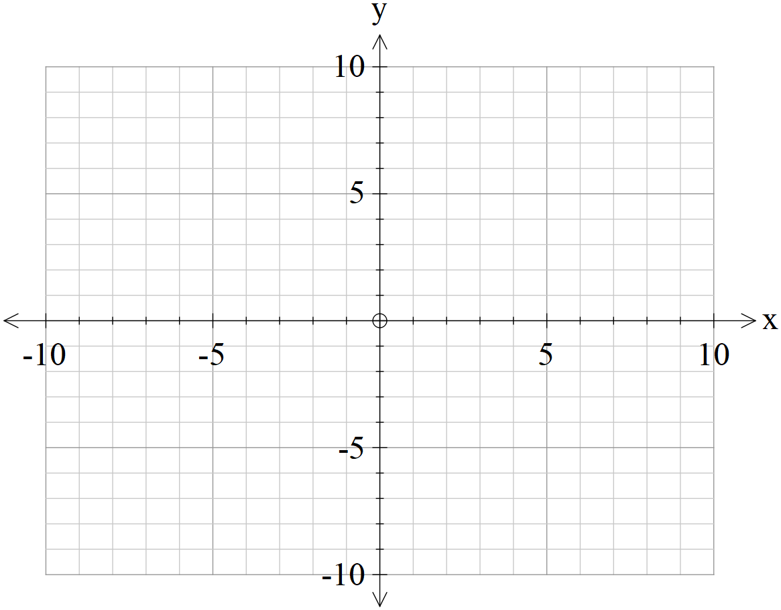

Question 5 (9 marks)

- Determine all roots of in exact polar form with principal arguments.
(4 marks)

- Plot all of these roots on the graph below showing all major features. (2 marks)

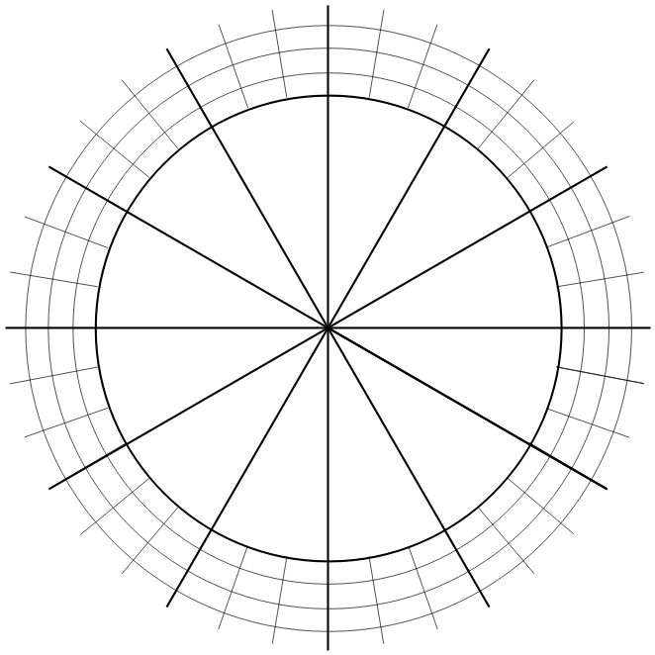

- If all the consecutive roots are joined by a straight line, determine the exact area of the polygon formed. (3 marks)

Question 6 (7 marks)

Determine all solutions of the following equations:
- and express in exact polar form with principal arguments.
(4 marks)

- and express in exact cartesian form. (3 marks)

Question 7 (9 marks)
A, B & C are 3 distinct points with non-zero position vectors respectively.
Given the following property of cross products and answer the following:

- If what can be deduced about and ? Explain. (3 marks)

- If what relationship exists between ? (3 marks)

- If and , prove that for some scalar . (3 marks)

Additional working space
Question number:

Additional working space
Question number:

Additional working space
Question number:

Acknowledgements

